Game Plan:

1. We have to make a multiplayer game where different players would be competing.
2. The goal for the players:

Increase GDP of the country as much as possible, while keeping in mind Fiscal deficit remains below 15% of GDP (we had kept a limit of 15%, and the code will warn him if his government spends above it, and thus the user would need to re-enter the government expenditure)

1. Below is the method whose code need to be generated:

**Glossary:** (assume 2011 to be year for which calculation need to made and 2010 be the year for which calculation is to be made)

C: Consumption of year 2010

C_new: Consumption of year 2011

I: Investment of year 2010

I_new: Investment for year 2011

G: Government expenditure for year 2011

MPC: marginal propensity to consume

t: tax rate (range: 0:100)

g_old: growth rate of year 2009

g: growth rate of year 2010

Y: GDP of country

F_def: Fiscal deficit of country

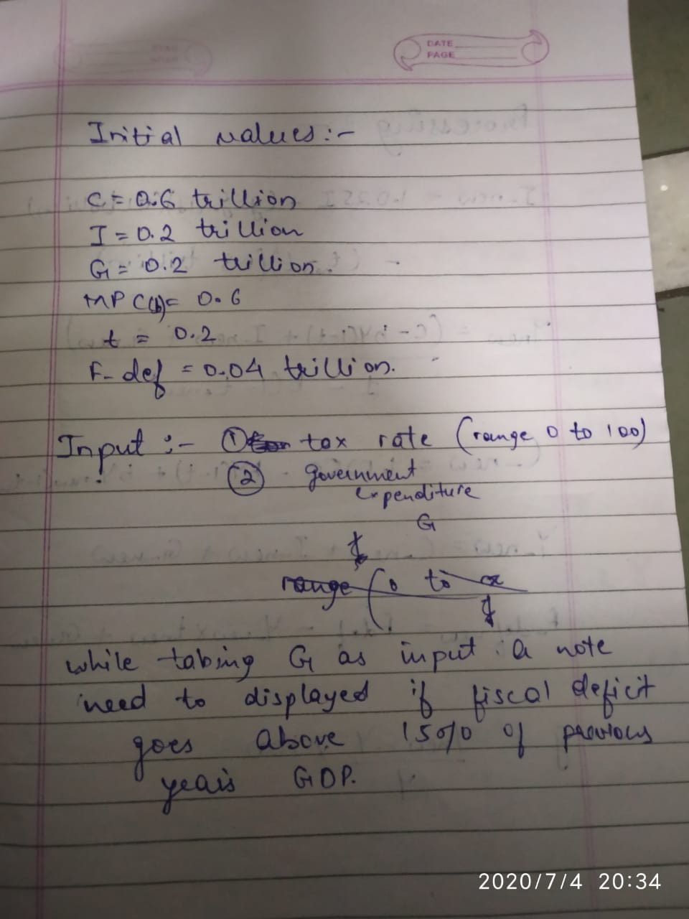

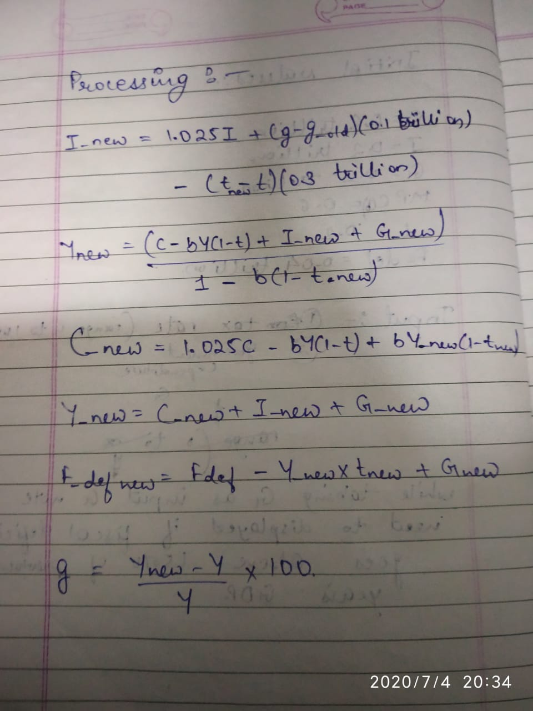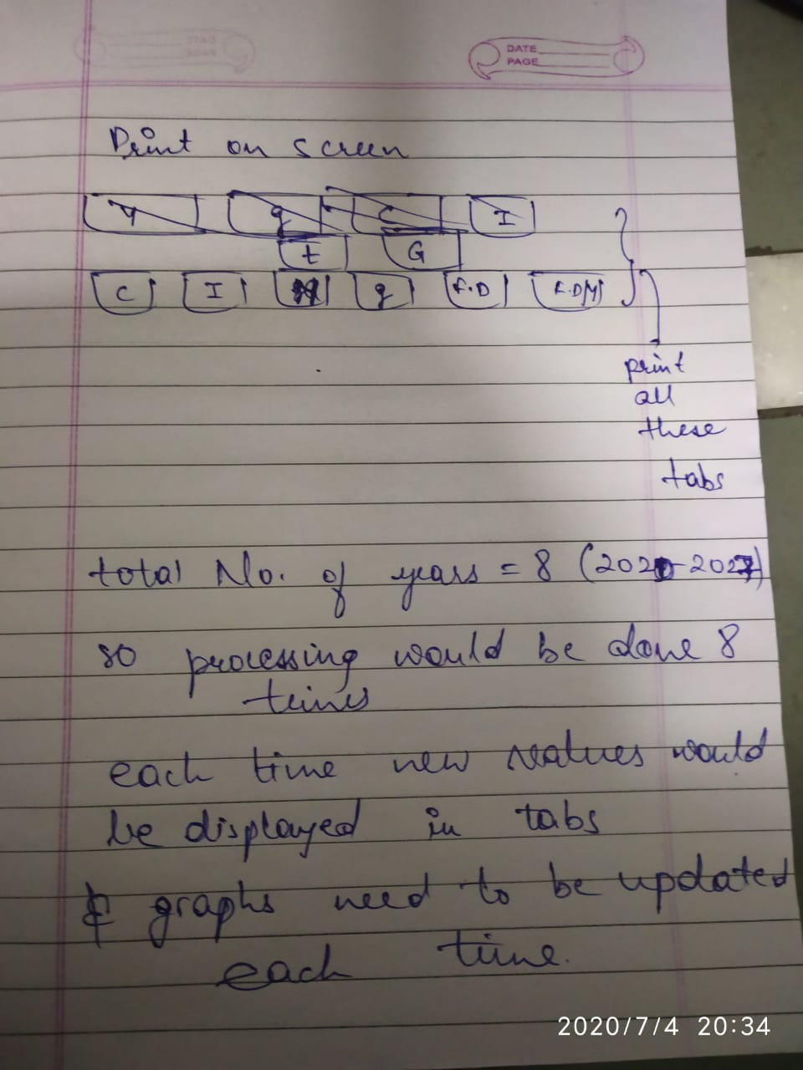

Also take g and g_old as given. g = 5, g_old = 4.5

1. While taking inputs it would be better if users can scroll on a slider to enter the values of government expenditure and tax rate instead of typing the values., because government expenditure is in range of trillions which is hard to type.

(esa slider rehna chahiye goverment expenditure and tax rate ke liye)

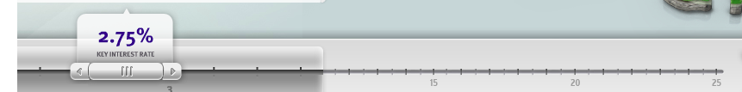

1. Seperate tab should be there titled Graphs where all important live graphs would be displayed for user to see and make decsions. Following are the grpahs whose live activity need to be displayed
2. Graph of the growth rate of the country.
3. Graph of graph of fiscal deficit as percent of GDP.
4. consumption, investment, government expenditure and GDP all on same graph

6. On the main screen there should be tabs as shown below which will show values for current year.

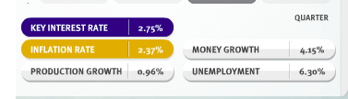

7. For stage 1 we are just making a single-player game. Then we would make it multiplayer at later stages.

8. I had also attached this sheet titled “Central Bank Policy War Plan of Action”

<https://docs.google.com/spreadsheets/d/1YMDRL-KyOt7SelahmAcOHfcVNAxbqWeQP3nOAA2rg5U/edit?usp=sharing>

I had made a broad plan of action. Please edit the plan of action as per you. Also add fine details of plan in plan of action in blank spaces.

Please complete the plan of action by tomorrow we would start working for further stage from Monday.

Let me know if something is still unclear :)